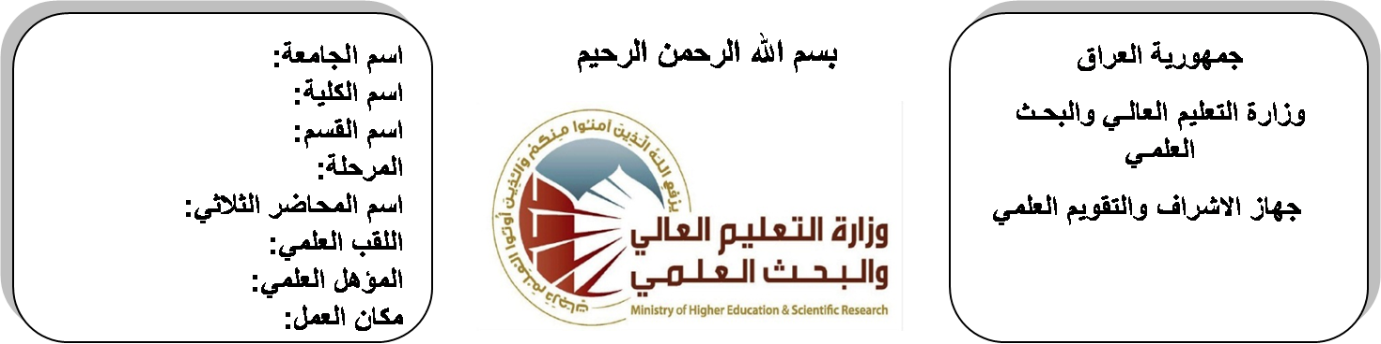

**Republic of Iraq**

**Ministry of Higher Education**

**& Scientific Research**

**University: Diyala University**

**College: College of Engineering**

**Department: Electronic Engineering**

**Stage: First**

**Lecturer name:Wisam Najm Al-Din Abed**

**Qualification:M.Sc.**

**Place of work: Electronic Dept.**

**(( Annual teaching plan form))**

|  |  |  |  |  |
| --- | --- | --- | --- | --- |
| **Lecturer Name** | **Wisam Najm Al-Din Abed** | | | |
| **Email** | **Wisam_alobaidee@yahoo.com** | | | |
| **Subject** | **Electrical Engineering Fundamentals** | | | |
| **Aims** | **The aim of these subjects is to make the students ready to undestand and comprehend the scientific theories and their applications related to their field of the study.** | | | |
| **Textbooks** | **Electrical Technology by Theraja** | | | |
| **Additional Textbooks** | **Electrical Engineering by Boylested** | | | |
| **Assessments** | **First Semester** | **Second Semester** | **Laboratory** | **Final Exam** |
| 20% | 20% | 10% | 50% |
| **Notes** |  | | | |

**Schedule Weekly Lessons - First Semester**

|  |  |  |  |  |
| --- | --- | --- | --- | --- |
| **Week** | **Date** | **Lectures** | **Lab. Experments** | **Notes** |
| 1 | **28/9** | System of units |  |  |
| 2 | **5/10** | voltage and current |  |  |
| 3 | **12/10** | circuit element |  |  |
| 4 | **19/10** | Resistances in series and parallel |  |  |
| 5 | **26/10** | Resistances in series and parallel |  |  |
| 6 | **2/11** | Basic terminology |  |  |
| 7 | **9/11** | the loop current method |  |  |
| 8 | **16/11** | the node voltage method |  |  |
| 9 | **23/11** | superposition theorem |  |  |
| 10 | **30/11** | thevenin's theorem |  |  |
| 11 | **7/12** | Norton's theorem |  |  |
| 12 | **14/12** | reciprocity, and maximum power transfer. |  |  |
| 13 | **21/12** | RMS and average values |  |  |
| 14 | **28/12** | circuit elements in the pharos domain , power factors. |  |  |
| 15 | **4/1** | Ac current through various circuit elements |  |  |
| 16 | **11/1** | operations with complex numbers, phasor diagrams. |  |  |
| Half Year holiday | 15/1 to  1/2 |  |  |  |

**Lecturer Signature Head of Dept. Signature Dean Signature**

**Schedule Weekly Lessons - Second Semester**

|  |  |  |  |  |
| --- | --- | --- | --- | --- |
| **Week** | **Date** | **Lectures** | **Lab. Experments** | **Notes** |
| 1 | **15/2** | Active, reactive and apparent power |  |  |
| 2 | **22/2** | power, power in a complex form , the power triangle |  |  |
| 3 | **1/3/2016** | Frequency response of various circuits |  |  |
| 4 | **8/3** | resonance in series and parallel circuits |  |  |
| 5 | **15/3** | quality factor, the half –power frequencies. |  |  |
| 6 | **22/3** | Loop and node voltage methods in ac circuits |  |  |
| 7 | **29/3** | circuit theorems in ac circuits. |  |  |
| 8 | **5/4** | Magnetic field |  |  |
| 9 | **12/4** | characteristics of lines of magnetic flux |  |  |
| 10 | **19/4** | magnetic field due to an electrical current |  |  |
| 11 | **26/4** | mmf, magnetic field strength |  |  |
| 12 | **3/5** | magnetic constants |  |  |
| 13 | **10/5** | reluctance |  |  |
| 14 | **17/5** | kirchoffs laws for magnetic circuits |  |  |
| 15 | **24/5** | series and parallel magnetic circuits |  |  |
| 16 | **1/6** | series and parallel magnetic circuits |  |  |

**Lecturer Signature Head of Dept. Signature Dean Signature**